Exercise 5.1 (X-ray diffraction of LCs)

In a diffraction experiment, Cu (K_{α}) radiation with a wavelength of 1.54 Ǻ is scattered by a liquid crystalline sample. Two reflexes are observed, an outer blurred halo with a cone angle β_{outer}= 40° and an inner sharp reflection at a cone angle of about β_{inner} = 6°.
a) What kind of liquid crystalline phase could give rise to this diffraction pattern?
b) Calculate the structural parameters of this phase.

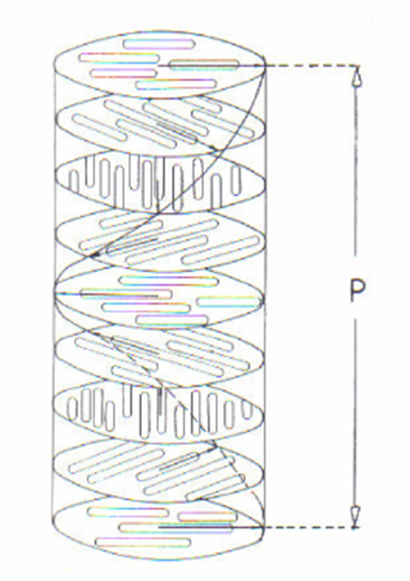
Exercise 5.2 (twisted nematic LCs)

In a twisted nematic (cholesteric) liquid crystal, polarized light passing through the crystal along the twist direction exits the crystal with a different polarization.
- Explain the origin of this phenomenon called optical activity
- Given that the refractive index of right handed circularly polarized light ($n_{R}$=1.55) and left handed circularly polarized light ($n_{L}$=1.50) are different, calculate the rotation of the incident polarization of the light beam after passing through the crystal with a thickness of 1 μm. The wavelength of the incident light is 500 nm.
- What would be the thickness required to turn the polarization by 90°?

